



adges UI components library

**Component ID #1 – ex-authentication - v1.1.0**

## Document Control

## Version History

|  |  |  |  |
| --- | --- | --- | --- |
| Version | Date | Author | Reason for Change |
| **1.0.0** | 3/4/2020 | Ahmed tawfik |  |
| **1.1.0** | 23/09/2020 | Rijin Mukundan |  |
|  |  |  |  |
|  |  |  |  |
|  |  |  |  |
|  |  |  |  |
|  |  |  |  |
|  |  |  |  |

## Review History

|  |  |  |
| --- | --- | --- |
| Version | Reviewer | Date |
|  |  |  |
|  |  |  |
|  |  |  |
|  |  |  |
|  |  |  |
|  |  |  |
|  |  |  |

Table of Contents

Document Control 2

Version History 2

Review History 2

1. Document and components Purpose. 4
2. General Information. 4
3. How to use. 4
4. Dependencies 5
5. Component features and configure. 5
6. How to configure component. 5
7. Examples 5

# 

# Document and components Purpose.

The purpose of the document is to guide how use and configure **ex-authentication** component.

# General Information.

Component Name: Authentication.

Extension Theme: ex-authentication.

Owner: Ahmed tawfik.

Version no: v1.1.0

**Design**

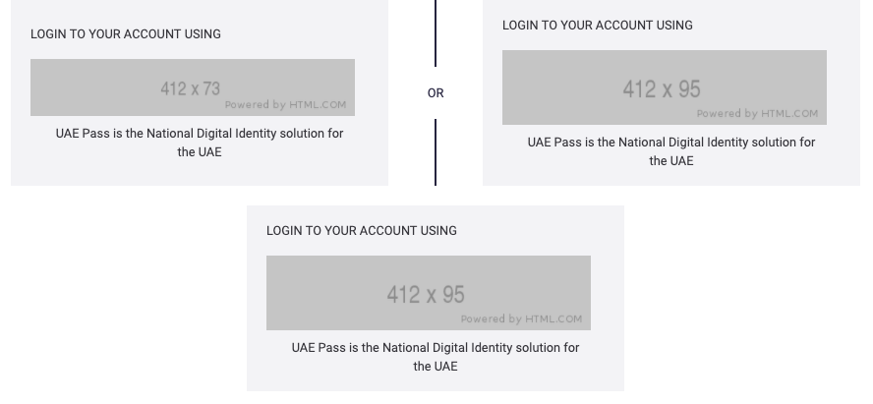

# How to use.

1. The available commands for this project .
   1. Compile : npm run gulp compile -- –path ex-authentication –extension
   2. Compile & include under ADGE tenant : npm run gulp compile -- –path ex-authentication –extension –full –dest [ADGEFolder]
   3. Deploy : npm run gulp deploy -- –path ex-authentication –extension
2. *Now project have full copy from this extension theme under the project theme and you can apply the project brand guideline and configure component based on project needs.*

# Dependencies

ex-layout

ex-main-theme

# Component features and configure.

You have access now to configure component with the below item.

$ex-announcement-background : $grey-800 !default;

$ex-announcement-primary-background : $primary-color !default;

$ex-announcement-secondery-background : $secondary-color !default;

$ex-announcement-padding : 20px !default;

$ex-dark-text-color : $black-color !default;

$ex-light-text-color : $white-color !default;

$ex-announcement-title-font-size : 24px !default;

$ex-announcement-title-font-size-mobi : 20px !default;

$ex-announcement-title-font-weight : 900 !default;

$ex-announcement-desc-font-size : 16px !default;

$ex-announcement-desc-font-weight : normal !default;

$ex-announcement-title-line-height : 30px !default;

$ex-announcement-title-line-height-mobi : 24px !default;

$ex-announcement-title-font-weight : bold !default;

$ex-announcement-remove-transition:all 0.8s !default;

$ex-announcement-defualt-title-color:$ex-light-text-color !default;

$ex-announcement-defualt-title-hover-color:$ex-light-text-color !default;

$ex-announcement-defualt-close-color:$ex-light-text-color !default;

$ex-announcement-defualt-close-hover-color:$ex-light-text-color !default;

$ex-announcement-defualt-desc-color:$ex-light-text-color !default;

$ex-announcement-defualt-desc-hover-color:$ex-light-text-color !default;

$ex-announcement-primary-title-color:$ex-light-text-color !default;

$ex-announcement-primary-title-hover-color:$ex-light-text-color !default;

$ex-announcement-primary-close-color:$ex-light-text-color !default;

$ex-announcement-primary-close-hover-color:$ex-light-text-color !default;

$ex-announcement-primary-desc-color:$ex-light-text-color !default;

$ex-announcement-primary-desc-hover-color:$ex-light-text-color !default;

$ex-announcement-secondary-title-color:$ex-light-text-color !default;

$ex-announcement-secondary-title-hover-color:$ex-light-text-color !default;

$ex-announcement-secondary-close-color:$ex-light-text-color !default;

$ex-announcement-secondary-close-hover-color:$ex-light-text-color !default;

$ex-announcement-secondary-desc-color:$ex-light-text-color !default;

$ex-announcement-secondary-desc-hover-color:$ex-light-text-color !default;

# How to configure component.

* There are various ways to configure the component:
* **CSS Class Configuration (on the variant)**
* **Adding Built-In or Bootstrap Class (on the variant)**
  + Spaces, Font weights, Display, Position properties etc can be added by bootstrap classes
    - i. Spacing: <https://getbootstrap.com/docs/4.0/utilities/spacing/>
    - ii. Flex: <https://getbootstrap.com/docs/4.4/utilities/flex/>
    - iii. Font: <https://getbootstrap.com/docs/4.0/content/typography/>
  + These classes should only be added to match the design
  + For built-in classes check 7 Below to see the entire list
* **SCSS Variable Override (on the _override.scss file)**
  + To configure the component we can take the above variables from section **4. Component features and configure** and add them to: adge-ph2/themes/<ADGE>/vars/_override.scss, this file with your desired changes to match the design.
* **Complete style override**
  + This should be the last and final option if the above 3 didn’t get you the desired output
  + This is overwriting the SCSS of the component by adding your own style to it
  + **Note: Take permission before doing this override**
  + Instructions:
    - Open the file /adge-ph2/themes/<ADGE>/sass/overrides.scss and add your own SCSS styles to override the faulty component.

# Examples

If you want to change login card background color:

$ex-authentication-login-cards:#ededed !default;

If you want to change login line color:

$ex-authentication-login-line-background-color: red !default;

If you want to change line text color “Or”:

$ex-authentication-login-line-text-color:blue !default;